***Team 12: American Options on S&P 500 (SPY)***

FE 620

April Ullrich, Varun Kandhari, & Hanish Pallapothu

**Introduction to American Options and Rationale for our chosen underlying security**

American options are a style of options that allows the holder to exercise an options contract any time up until their expiration. This gives them flexibility with their options trading strategy. One of the biggest advantages of these options is that one can exercise the contracts as soon as they are in the money or whenever the price moves in a beneficial direction.

The two types of American options that can be traded on the exchange are American call options and American put options. An American call option provides the holder with the opportunity to demand delivery of the underlying security or stock within the time horizon of the contract if the underlying price exceeds the strike price. On the other hand, an American put option grants the holder the right to demand for the buyer to take possession of the underlying asset once the price of the underlying asset drops below the strike price.

Since investors have the freedom to exercise their options at any point during the life of the contract, American-style options are more valuable than the limited European options. However, the ability to exercise early carries an added premium or cost.

**Underlying Asset - S&P 500 Index Option (SPY)**

We are using the S&P 500 index as an underlying asset in this project. It is a stock market index that measures the stock performance of 500 large companies listed on stock exchanges in the United States. It is one of the most commonly followed equity indices. We will price the options using a binomial tree implementation.

**Rationale for using Index Options**

**Diversification :**

One of the main reasons why we chose an index as our underlying asset is due to the Diversification it provides. A stock index is a compilation of many stocks.The S&P 500 is meant to resemble a portfolio made up of 500 [individual companies](https://www.optiontradingtips.com/resources/historical-data/sp500.html).

**Liquidation :**

Index options are very popular for option traders. This popularity drives up the volumes available to trade and reduces the spreads that are quoted in the market.This competition means that you will always have a fair price to trade at and plenty of volume too.

**Binomial Tree Pricing**

Under this model, we split the time to expiration of the option into equal periods (weeks, months, quarters). The model then follows an iterative method to evaluate each period, that considers either an up or down movement and their probabilities. Effectively, the model creates a binomial distribution of possible stock prices.

**Assumptions**

When setting up a binomial option pricing model, we need to be aware of the underlying assumptions, to understand the limitations of this approach better.

* At every point in time, the price can go to only two possible new prices, one up and one down.
* The underlying asset pays no dividends;
* The interest rate (discount factor) is constant throughout the period;
* The market is frictionless, and there are no transaction costs and no taxes;
* Investors are risk-neutral, indifferent to risk;
* The risk-free rate remains constant.

**Advantages of the Binomial Tree Model**

* The Model is mathematically simple to calculate
* Binomial Option Pricing is useful for American options, where the holder has the right to exercise at any time up until expiration.

**Disadvantages of the Binomial Tree Model**

* A notable disadvantage is that the computational complexity rises a lot in multi-period models.
* The most significant limitation of the model is the inherent necessity to predict future prices.

**Binomial Tree Method**

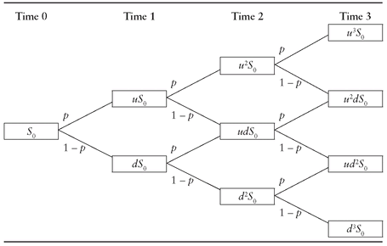

The call option value using the one-period binomial model can be worked out using the following formula:

Where p is the probability of an up move which in determined using the following equation:

Where r is the risk free rate, u equals the ratio of the underlying price in case of an up move to the current price of the underlying and d equals the ratio of the underlying price in case of a down move to the current price of the underlying.

**Payoff of the Call Option**

|  |  |  |  |
| --- | --- | --- | --- |
| **Period 1 Price** | **Period 2 Price** | **Underlying Price at Expiration** | **Call Option Payoff** |
| Up | Up | uuS | Max(uuS-X,0) |
| Up | Down | udS | Max(udS-X,0) |
| Down | Up | duS | Max(duS-X,0) |
| Down | Down | ddS | Max(ddS-X,0) |

**Market Data Analysis**

From Yahoo Finance, we downloaded historical market data of the daily prices for the S&P 500 ETF (SPY) as well as the 13 Week Treasury Bill rate. The acquisition of this data in R using the quantmod package can be viewed in our code appendix.

**Analysis of SPY Stock Price Time Series**

We chose to use the daily close prices of the SPY for the past 6 months as our underlying price series ending on May 4th, 2021. *Figure 1* below depicts this time series of SPY daily close prices.

*Figure 1: Historical Daily SPY Close Prices*

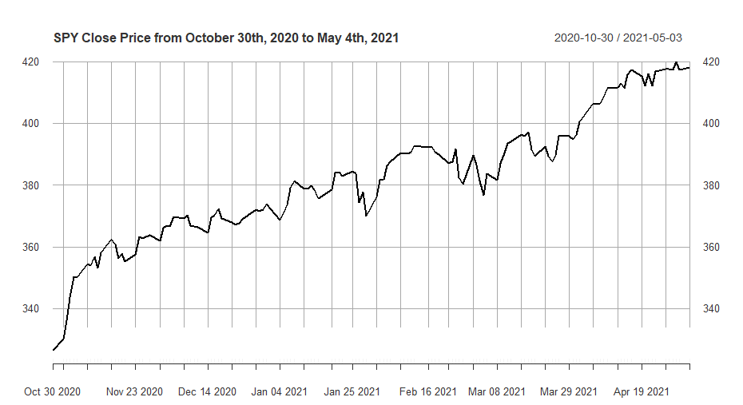

From the time series of daily close prices , we can compute the daily log returns using the formula: . Under the principles of the Black-Scholes model, the log returns are normally distributed with a mean and variance( where the value of as the time interval is one day in the trading year of 252 days. In order to check whether the SPY log returns follow the Black-Scholes requirement of normally distributed, we must examine the Q-Q plot of the returns as shown below in *Figure 2*.

*Figure 2: Q-Q Plot of SPY Log Returns*

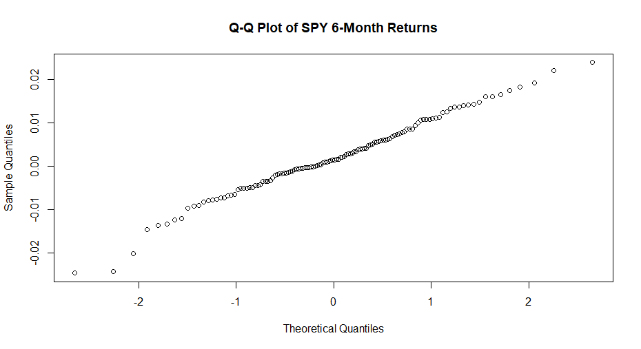

The Q-Q plot indicates a normal distribution if the points follow a straight diagonal line. Thus, based on *Figure 2*, the SPY log returns indeed approximately follow a normal distribution and we can use the Black-Scholes model in conjunction with the Binomial tree model as described in our pricing algorithm. Although the tails of the plot follow a more curved trend, this aligns with the expectation that market financial asset returns typically have heavy-tailed distributions.

**Estimating the Historical Volatility of SPY**

The closing price time series of the SPY, can be used to estimate the historical volatility of the underlying using the following formula:

with the standard error of this estimate computed as:

Here n represents the number of days in the lookback window. We computed the historical volatilities for three varying lookback window lengths of 1 month, 3 months, and 6 months. The results of our estimations can be found below in *Table 1*.

*Table 1: Estimated Historical Volatilities for SPY stock on 4-May-2021*

|  |  |  |
| --- | --- | --- |
| Lookback Window | Days |  |
| 6-Apr-2021 to 4-May-2021 | 20 | () % |
| 2-Feb-2021 to 4-May-2021 | 63 | () % |
| 30-Oct-2021 to 4-May-2021 | 126 | () % |

**Estimating the risk-free rate from the 13 Week Treasury Bill**

For our risk-free rate for our option pricing model, we choose the 13 Week Treasury Bill. We analyzed the prices for the past month ranging in date from April 4th, 2021 to May 4th, 2021 as shown in *Figure 3*. The closing value on May 4th was 0.0001%. We will use this value as our risk-free rate to price the SPY American options. The risk-free rates are notably low during this time period since the Fed lowered rates as a result of the COVID-19 pandemic crisis.

*Figure 3: 13 Week Treasury rate from April 4th, 2021 to May 4th, 2021*

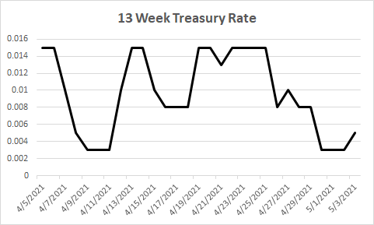

**Pricing American Options for SPY**

Several options are traded on SPY. As of 4-May-2021, the first expiries are 21-May-2021, 18-June-2021, 30-June-2021. *Figure 4* demonstrates a sample of the prices of call and put options for varying strikes for the 21-May-2021 contract, taken from Bloomberg.

*Figure 4: Call and Put Option prices on the SPY for 21-May-2021*

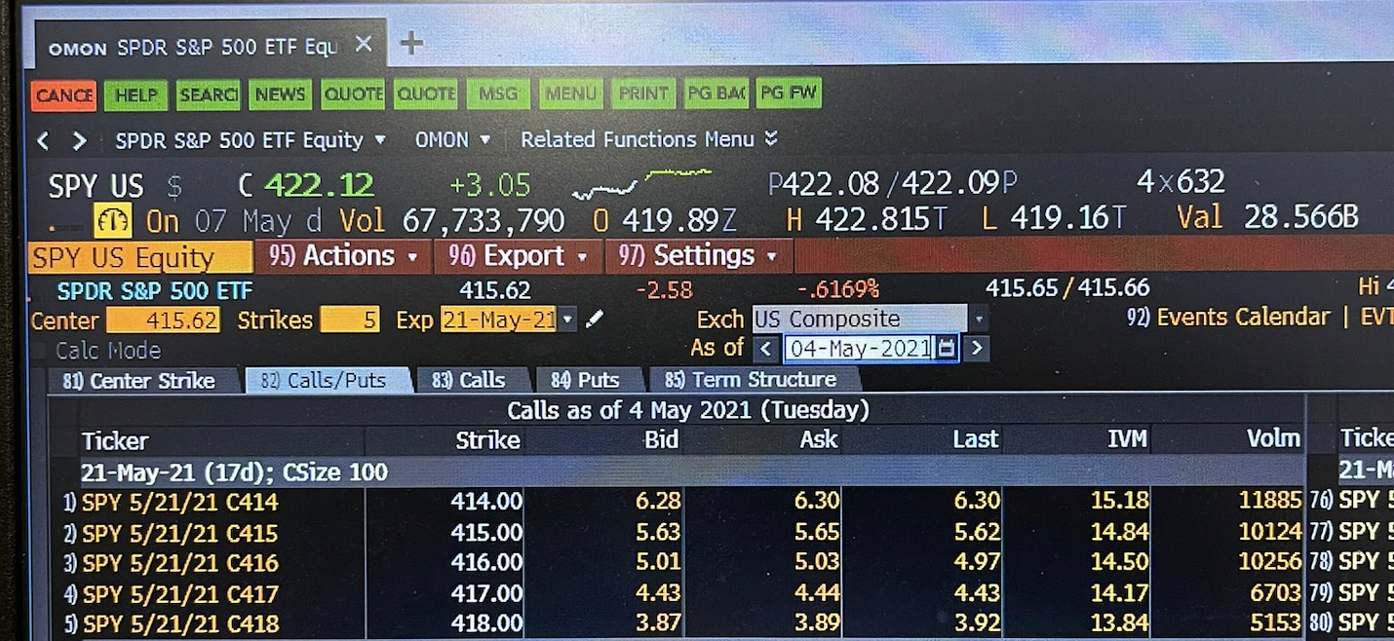

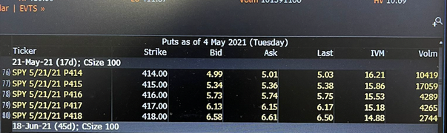

By using the mid-prices m(K) = (a(K) + b(K)), we can test the put-call parity inequalities for American option prices. Recall the bounds on the prices of the American options on stocks which do not pay a dividend.

For short maturity options the discount factor is almost 1 so the upper and lower bounds are very close. *Figure 5* depicts the difference of the mid- prices for the 21-May-2021 maturity options, which are represented by the blue dot,s in comparison to represented by the black line. As we can see the two series are relatively similar.

*Figure 5: is represented by the blue dots & is represented by the black line*

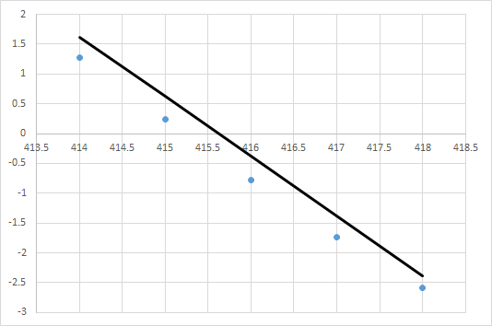

We would like to price these American options in the Black-Scholes model using a binomial tree approach. Specifically, we would like to investigate pricing the options expiring on May 21st, 2021. Since we are conducting this investigation starting on May 4th, the time to expiration for the option can be expressed as follows:

21 May 2021 : T = 17/252 years

Note that we use 252 days instead of 365 as 252 represents the number of trading days in a given year. One key aspect of the binomial tree we must determine is the number of n time steps we should utilize. This is a very important decision as its choice will greatly impact the results of our model. In order to best determine the number of steps, we examine the convergence of the prices as n becomes increasingly large.

**Sensitivity study**

First, we shall price one of the American options in order to evaluate the dependence of its price relative to the number of time steps n, while keeping the option maturity fixed at

For the purpose of this examination, we have chosen to focus our analysis on the put option with expiry 21-May-2021 and strike K = 416 which is closest to the at-the-money point The binomial tree with n = 4 daily time steps gives the price:

**P(K = 416; n = 4) = 6.06**

*Figure 6: Binomial Model Prices for May 21st Contracts from R*

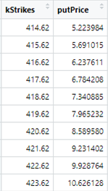 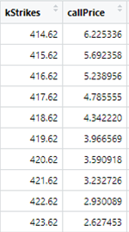

*Figure 7: Convergence of American Put option prices in the binomial tree model as the number of time steps n increases. Put option with n=4 time steps (blue) and n=100 time steps (green)*

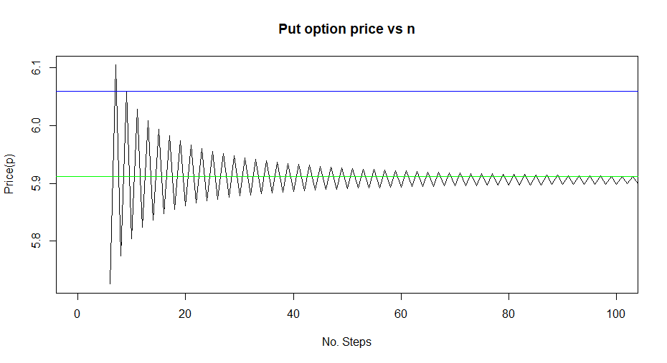

*Figure 8: Convergence of American Call option prices in the binomial tree model as the number of time steps n increases. Put option with n=4 time steps (blue) and n=100 time steps (green)*

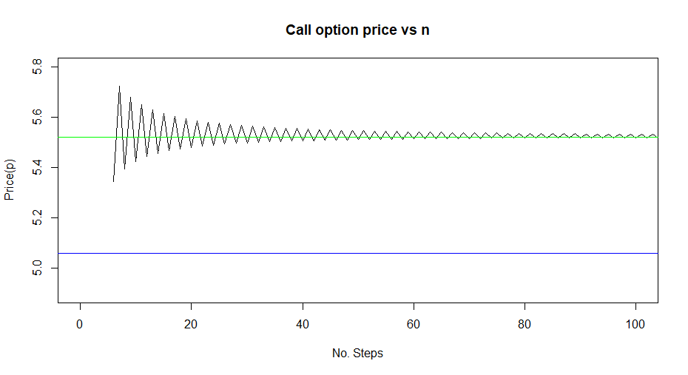

To determine how accurate this price using n = 4 time steps is, we can examine *Figure 7*. The black line in Figure 7 depicts the price of the put option as n increases from 5 to 100. Examining the graph, we can observe that the prices converge for a sufficiently large value of n. For example, when n = 100 time steps we have the following valuation:

**P(K = 416; n = 100) = 5.91**

The put option price with n = 100 is shown as the green line and the n = 4 value as the blue line. It is evident that the n = 100 value is more accurate. Another evaluation of our binomial tree pricing model can be executed if we utilize the principle that American call options on a stock which does not pay dividends have the same price as European call options with the same strike and time to maturity.

The table below displays the binomial tree price of the American call option with strike of K = 416 for various values of n, the time steps of the tree. We can observe that as n increases, the binomial tree prices converge to the European call option price, as expected.

*Table 2: Convergence of American Call Option Price to European Call Option Price*

|  |  |  |  |  |  |  |  |  |
| --- | --- | --- | --- | --- | --- | --- | --- | --- |
| n | 4 | 10 | 20 | 30 | 40 | 50 | **100** | **BS** |
| C(K=416) | 5.248 | 5.425 | 5.482 | 5.499 | 5.507 | 5.512 | **5.5212** | **5.5205** |

This same convergence can also be observed graphically in *Figure 8*.

*Table 3:* American Option Prices on the SPY as of 4-May-2021 with expiry on 21-May-2021. The Binomial columns show the results of our binomial tree model with n = 100 time steps, a historical volatility of (3-month lookback window), and the risk free rate of 0.0001%. The BS column displays the European Call Option price using the same parameters in the Black-Scholes model. Lastly, the Bid-Ask Spread column displays market price of the Option. The closing price of the SPY on the day of evaluation was , thus options closest to the ATM point are highlighted in green.

|  |  |  |  |  |  |
| --- | --- | --- | --- | --- | --- |
|  | **CALL OPTION** | | | **PUT OPTION** | |
| Strike K | Binomial | BS | Bid-Ask Spread | Binomial | Bid-Ask Spread |
| 414.00 | 6.56 | 6.54 | [6.28, 6.30] | 4.93 | [4.99, 5.01] |
| 415.00 | 6.02 | 6.02 | [5.63, 5.65] | 5.40 | [5.34, 5.36] |
| **416.00** | **5.52** | **5.52** | **[5.01, 5.03]** | **5.90** | **[5.73, 5.74]** |
| 417.00 | 5.06 | 5.05 | [4.43, 4.44] | 6.45 | [6.13, 6.15] |
| 418.00 | 4.61 | 4.61 | [3.87, 3.89] | 6.99 | [6.58, 6.61] |

**Analysis of Options Pricing: Market vs. Model**

*Table 3* above displays the collective results comparing the market vs. binomial tree model for the American options on the SPY with expiry 21-May-2021. The binomial tree prices for both the call and put options are all consistently below the market prices the options are trading at. One potential source of explanation for these results can be found by considering the implied volatility of the American options. By definition, the implied volatility is the value of volatility that recreates the observed market option price using the Black-Scholes model.

* One important aspect of implied volatility is dependent on the strike of the option. This relationship is graphically depicted by the implied volatility smile. It signifies that we are not able to reproduce all possible market option prices using a single volatility.
* We must also consider the fact that our binomial tree pricing and the Black-Scholes model assume a universal volatility for all strike prices, which in our case was the 3-month historical volatility.
* In practice, the historical volatility is usually lower than the implied volatility. The reason for this is that investors in the options market are depicting risk averse attitudes as they are willing to overpay for options to hedge their portfolios in the event of a market downturn.

**Greeks Calculation**

Below are the Delta and Gamma plots for Call option

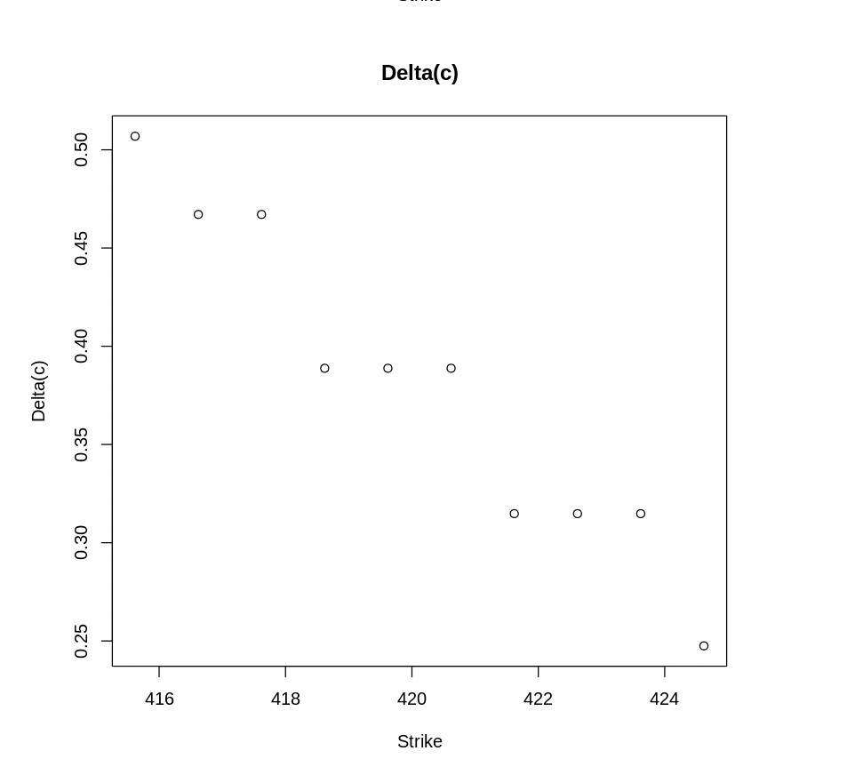 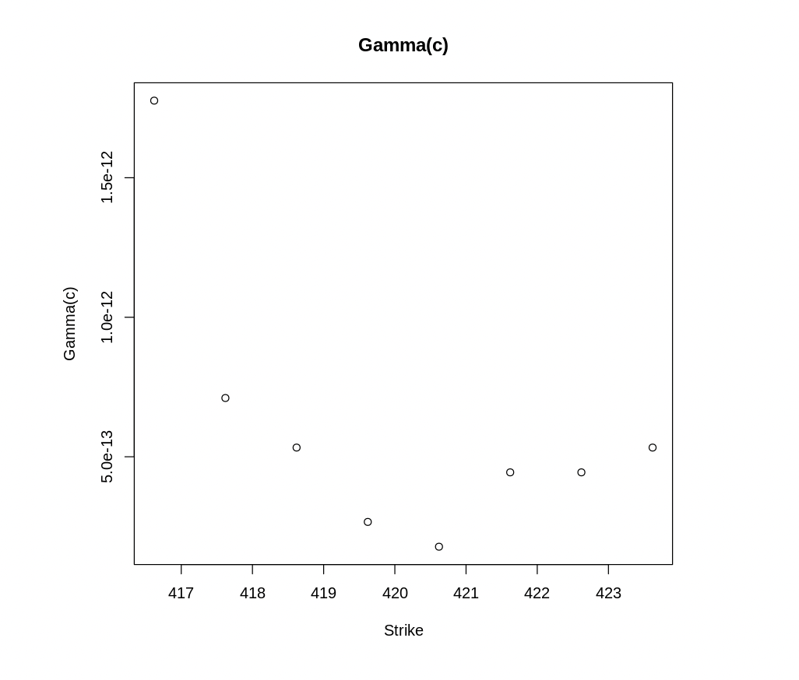

Below are the Delta and Gamma plots for Put option:

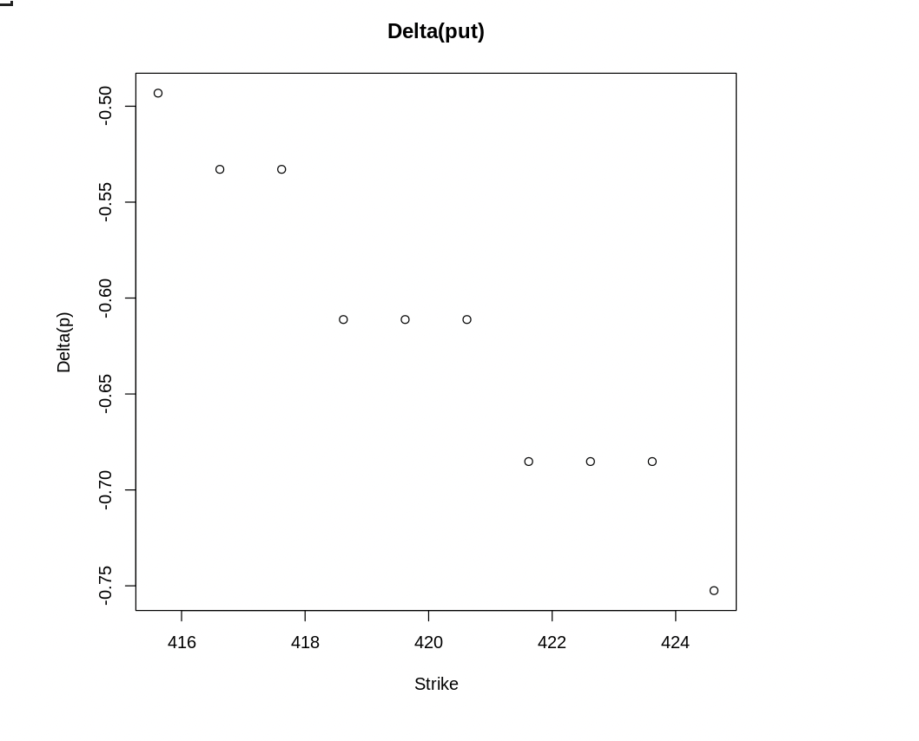 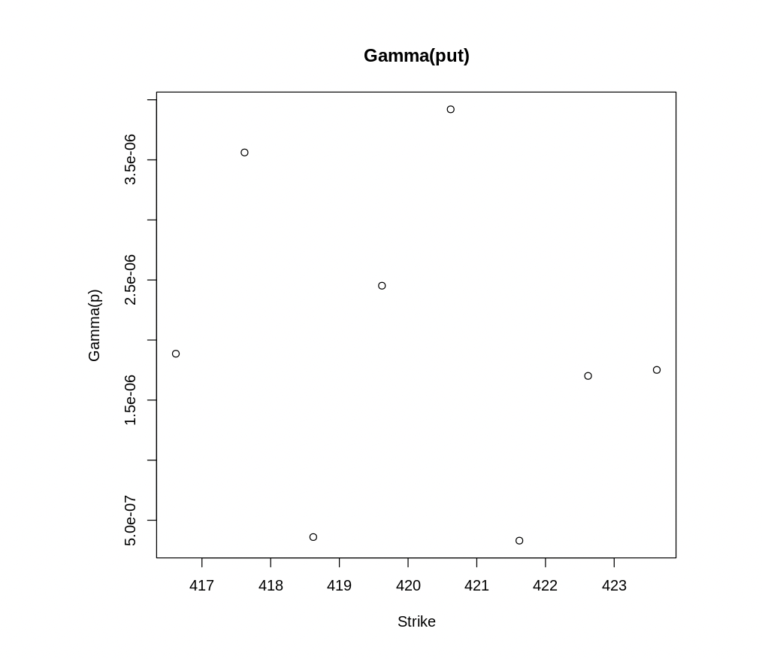

Delta is calculated by utilizing the central finite differences with step

Gamma is calculated using the same collection of points

The delta and gamma for the call and put options maturing on 21-May-2021 are observed in the plots above. The actual values for these greeks can be found in the R output below.

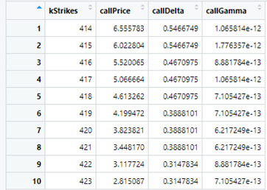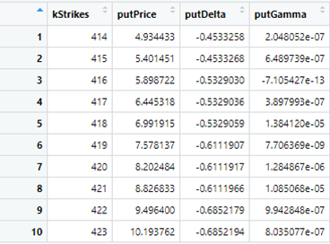

* In observation, we see that the Greeks are very noisy inherently due to the nature of the Binomial Tree model. For example, the put option with strike 416 has a negative gamma value which does not make sense as gamma should always have a positive value. This is one of the major flaws of the binomial tree model.

**Hedging Strategy**

We can consider the closing SPY prices for four days after May 4th, 2021 as obtained from Yahoo finance using the quantmod R package shown below:

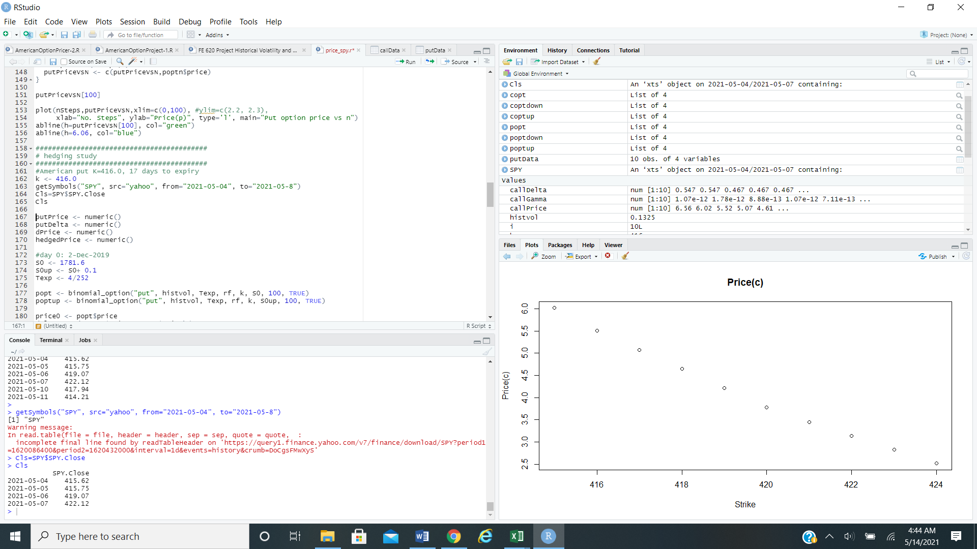

For the purpose of this exercise, we will consider the put option with strike K = 416, as it moves closer to expiry.

*Table 4: Delta Hedging for American Put Option with Strike K = 416*

|  |  |  |  |  |  |  |
| --- | --- | --- | --- | --- | --- | --- |
| Day | Maturity |  | Put Price | Delta |  |  |
| 4-May-2021 | 17/252 | 415.62 | 5.90 | -0.5329 |  |  |
| 5-May-2021 | 16/252 | 415.75 | 5.66 | -0.5331 | -0.24 | -0.1707 |
| 6-May-2021 | 15/252 | 419.07 | 3.99 | -0.3760 | -1.67 | 0.0999 |
| 7-May-2021 | 14/252 | 422.12 | 2.73 | -0.3031 | -1.26 | -0.1132 |

For each day, we compute the put option price as well as the Delta using our binomial tree model. The results are shown in *Table 4* including the construction of a dynamically hedged portfolio consisting of one put option and shares of stock in the SPY. We denote the combined position of option and stock by . The daily change in price of the hedged portfolio can be computed as follows:

The results for this computation can be found in the last column of Table 4. In order for the hedge to work properly, it must be adjusted daily according to the delta of the put option. The hedged position reduces the daily price volatility in comparison to the naked put option. However, it must be noted that the hedged position is not perfect due to variations caused by other greeks of Theta and Gamma as well as the fact that we are using finite time intervals as opposed to continuous re-hedging.

**Next Steps**

If we had additional time some other aspects we could consider are:

* How would the accuracy of our model change if we utilized other historical volatility lookback windows instead of the 3-month one we chose.
* Consider a trinomial tree model to help reduce the noisiness of the greeks observed from the binomial tree model.
* Investigate implied volatility relative to the historical volatility and see if that can explain why we observed higher prices using our binomial model as opposed to those observed in the market.

**References**

J. Hull, Options, Futures and Other Derivatives, Pearson 10th Edition

**Code Appendix**

R Code for estimating option prices using binomial tree model

S0 <- 415.62

Texp <- 17/252

histvol <- 0.1325

kStrikes <- numeric()

callPrice <- numeric()

putPrice <- numeric()

callDelta <- numeric()

callGamma <- numeric()

putDelta <- numeric()

putGamma <- numeric()

for (i in 1:10) {

k <- 415.62 + 1*(i-1)

S0up <- S0 + 0.1

S0down <- S0 - 0.1

copt <- binomial_option("call", histvol, Texp, rf, k, S0, 100, TRUE)

coptup <- binomial_option("call", histvol, Texp, rf, k, S0up, 100, TRUE)

coptdown <- binomial_option("call", histvol, Texp, rf, k, S0down, 100, TRUE)

popt <- binomial_option("put", histvol, Texp, rf, k, S0, 100, TRUE)

poptup <- binomial_option("put", histvol, Texp, rf, k, S0up, 100, TRUE)

poptdown <- binomial_option("put", histvol, Texp, rf, k, S0down, 100, TRUE)

kStrikes <- c(kStrikes,k)

callPrice <- c(callPrice,copt$price)

callDelta <- c(callDelta,(coptup$price - coptdown$price)/0.2)

callGamma <- c(callGamma,(coptup$price + coptdown$price - 2*copt$price)/0.01)

putPrice <- c(putPrice,popt$price)

putDelta <- c(putDelta,(poptup$price - poptdown$price)/0.2)

putGamma <- c(putGamma,(poptup$price + poptdown$price - 2*popt$price)/0.01)

}

callData <- data.frame(kStrikes,callPrice, callDelta,callGamma)

putData <- data.frame(kStrikes,putPrice, putDelta,putGamma)

putData

callData

R Code for plotting Delta and gamma values for Call and Put Options.

# plot the call option price, delta and gamma vs K

plot(kStrikes, callPrice,

xlab="Strike", ylab="Price(c)", type='p', main="Price(c)")

plot(kStrikes, callDelta,xlab="Strike", ylab="Delta(c)", type='p',

main="Delta(c)")

plot(kStrikes[2:9], callGamma[2:9],xlab="Strike", ylab="Gamma(c)", type='p',

main="Gamma(c)")

# plot the put option price, delta and gamma vs K

plot(kStrikes, putPrice,

xlab="Strike", ylab="Price(p)", type='p')

plot(kStrikes, putDelta,xlab="Strike", ylab="Delta(p)", type='p',

main="Delta(put)")

plot(kStrikes[2:9], putGamma[2:9],xlab="Strike", ylab="Gamma(p)", type='p',

main="Gamma(put)")